**Yifeng Huang**

**ART101 - Programming for the Arts 2024 Spring Quarter**

**Lab 4: Pseudocoding and Problem-solving 4/24/2024**

**Link to the lab assignment result**

<https://yhuan359.github.io/art101/lab4/index.html>

**Task 1: Pseudocode an everyday task**

Changing the laptop battery:

1. Look for the right battery model and order it
2. Unscrew the cover on the bottom of the laptop
3. Remove bolts around the battery
4. Take the original battery out
5. Put in the new battery
6. Screw the bolts back in to secure the battery
7. Put back the cover on the back for the laptop
8. Turn on the laptop and charge the battery to validate if the new battery works.

**Task 2: Pseudocode a simple computer game**

**Blackjack card game:**

Creating a Blackjack card game:

1. Set the rule of game winning, eg. Points of the cards more than 17.
2. Display two cards to the user.
3. Ask the user if she/he wants another card.
4. If the user doesn’t want, stop.
5. If the user want additional card, display one more and ask again.
6. When the user stops taking more card, calculate the total points from the cards.
7. Determine if the user loss or win.

**Summary of Efforts**

This is my 2nd submission for this assignment after reviewing the class materials and the requirements of the lab assignment. Since I don’t have a partner for the assignment, I discussed with my friends instead to clarify what I did was following the direction.

I did not do it right in the 1st submission because I did not have the correct settings in the template and not follow the instruction through the work. I started over the GitHub and local setup in Lab 3, and re-did the Lab 4 based on the settings.

It’s great to learn this Pseudocode for the problem solving that can be applied to the daily living and especially for the coding. It provides a clear picture and steps what the problem is and how the solve it step by step when creating the codes.

I re-submitted this assignment for the teacher to review and re-grade if needed. Thanks.

**Screenshots**

Task 3: Turn pseudocode into comments, in lab4/js/lab.js 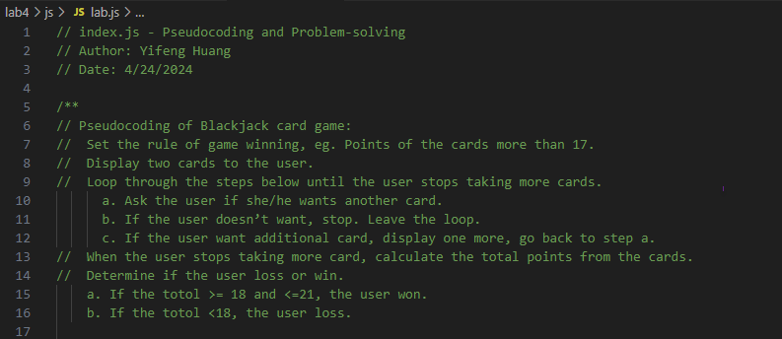

Task 4: Create an index.html for Lab 4

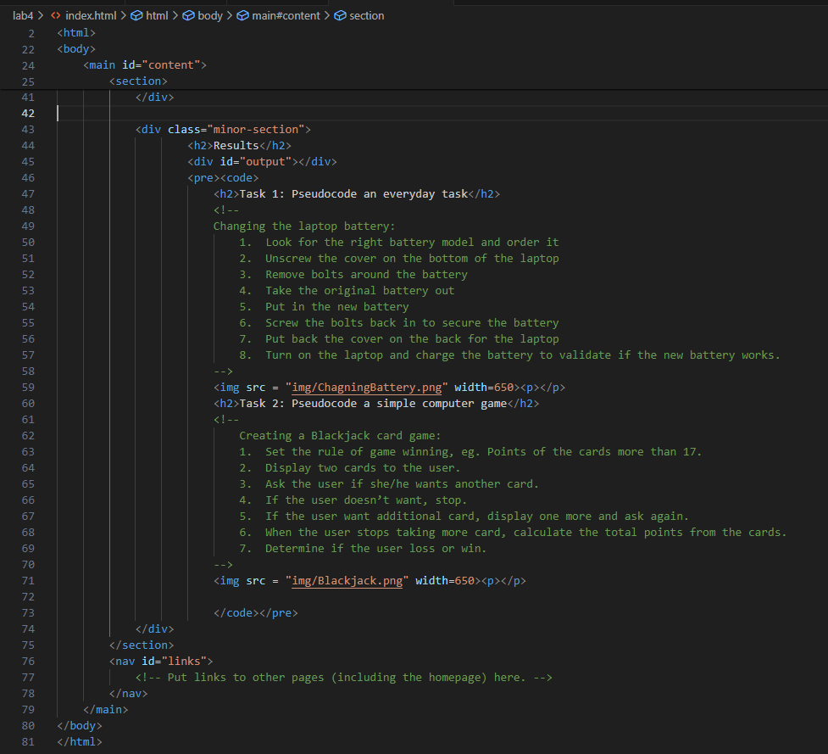

**Self Evaluation Rubric**

|  |  |  |  |  |  |  |
| --- | --- | --- | --- | --- | --- | --- |
| Self Evaluation Rubric | | | | | | |
| Did you complete the assignment and did you complete it on time? | Submitted on time | Up to 1 day late | Up to 2 days late | Up to 3 days late | Up to 4 days late | **Do you need to clarify?** |
| 口 | 口 | 口 | 口 | 口 | 1st submit was on-time. Resubmitted it with corrections 2 days later. |
| Did you collaborate with a partner? | A lot of effort |  | Some effort |  | Not this time | **Do you need to clarify?** |
| 口 |  | 口 |  | 口 |  |
| Did you put in earnest effort and provide an articulate summary of your experience? | Excellent | Pretty good | About average | Could be improved | Not this time | **What supports this?** |
| 口 | 口 | 口 | 口 | 口 |  |
| Was the assignment complete, with minimal errors, correct output, and good style? | Excellent | Pretty good | About average | Could be improved | Not this time | **What supports this?** |
| 口 | 口 | 口 | 口 | 口 | My 1st submission did not meet what is required. The 2nd submission started over and corrected the mistakes |
| How much EXTRA effort did you put into the assignment? | A lot of extra effort |  | Some extra effort |  | Not this time | **What supports this?** |
| 口 |  | 口 |  | 口 | I had a second thought what I should do to meet the requirement, and re-did the assignment over again. |
| **Summary of your evaluation/efforts:** | | | | | | |
| This is my 2nd submission for this assignment after reviewing the class materials and the requirements of the lab assignment. Since I don’t have a partner for the assignment, I discussed with my friends instead to clarify what I did was following the direction.  It’s great to learn this Pseudocode for the problem solving that can be applied to the daily living and especially for the coding. It provides a clear picture and steps what the problem is and how the solve it step by step when creating the codes. | | | | | | |